# EPPS 6356 — Data Visualization Assignment 3

This document compiles the outputs and brief explanations for Assignment 3. All plots were produced in R and shown in the RStudio Plots pane. Short explanations and interpretations accompany each figure.

## VADeaths Stacked Bar Chart (Base R)

Stacked barplot of the built-in VADeaths matrix. Bars represent population groups; stacked segments encode age cohorts. Labels are centered in segments using cumulative sums.

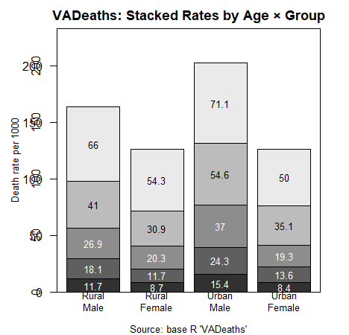

## Anscombe’s Quartet — Regression & Style Comparison (Base R)

Four models share nearly identical summaries (slope ≈ 0.5, intercept ≈ 3, R² ≈ 0.667, SE ≈ 1.236), yet visual structures differ. Panel varies point symbols, line types, and colors.

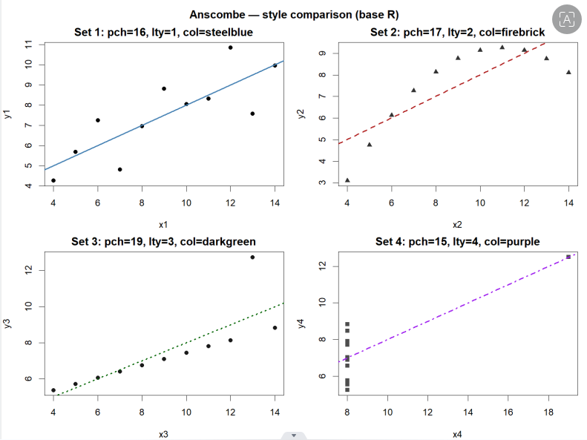

## Fine-Tuned Base Plot (Serif Font, Custom Colors, pch)

Typography and styling customizations: serif fonts via par(family='serif'), custom hex colors, star-shaped plotting symbol (pch = 8), and a dashed regression line.

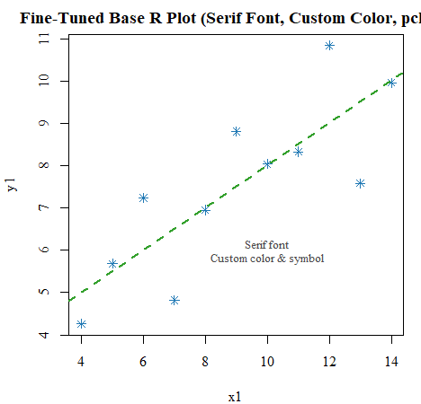

## Anscombe with ggplot2 (Faceted Panels)

Faceted ggplot2 version using triangular points, dashed regression fits, and a serif minimal theme.

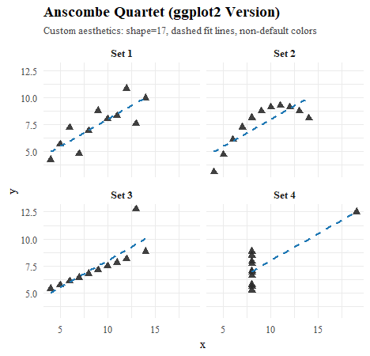

## COVID Deaths in Europe (Daily Time Series)

Pink points show each European country’s daily new deaths; the darker pink curve is a median smooth across countries. Country labels (Spain, Germany, Ukraine, Italy) are placed to match the assignment reference.

